Project Design Phase-II
Data Flow Diagram & User Stories
Date | 20 July 2026
Team ID
Project Name | Plugging Into the Future: An Exploration of Electricity Consumption Patterns
Maximum Marks | 4 Marks

Data Flow Diagram
Raw Dataset -> Microsoft SQL Server (Cleaning, Transformation, Querying) -> Processed/Aggregated Data -> Tableau (Visualization & Dashboards) -> Flask Web Application (Presentation Layer) -> End User (Browser).
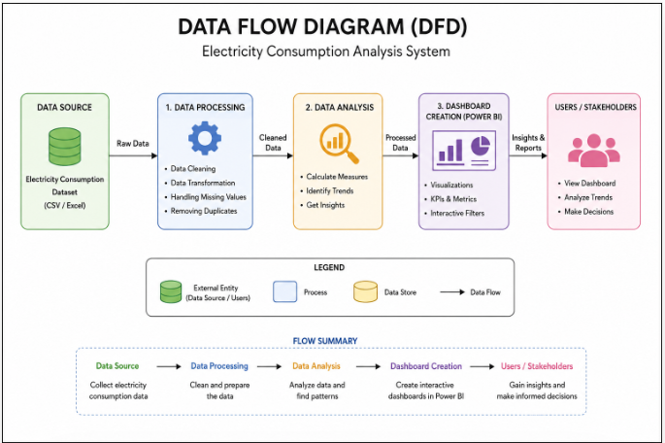

User Stories
User Type | Functional Requirement (Epic) | User Story Number | User Story / Task | Acceptance Criteria | Priority | Release
End User | Dashboard Access | USN-1 | As a user, I can open the web app and view the state-wise consumption dashboard. | Dashboard loads with current data | High | Sprint-1
End User | Dashboard Access | USN-2 | As a user, I can filter the dashboard by state, region, and year. | Filters update the visuals correctly | High | Sprint-2
End User | Trend Analysis | USN-3 | As a user, I can view year-over-year consumption trends. | Trend chart reflects selected range | Medium | Sprint-2
Data Analyst | Data Pipeline | USN-4 | As an analyst, I can rely on the dataset being cleaned and de-duplicated before analysis. | No missing/duplicate values in processed tables | High | Sprint-1
Data Analyst | Data Pipeline | USN-5 | As an analyst, I can run aggregation queries by state/region/time. | Queries return correct aggregated totals | High | Sprint-1

